

**جــامـعـة الإسراء الخــاصــة**

**كـليـة تكـنولوجيـا المعلومـات**

**Isra University**

**Faculty of IT**

**First Semester 2023/2024**

|  |  |  |
| --- | --- | --- |
| Course Title: DATA BASE | Course No.: | HW No :  2 |
| Submitted to: Dr. Maher Abuhamdeh | | |
| Student Number:  AE2279 | Student Name:  KAWTHER MAHARMEH | Date:  15/5/2024 |

You need to solve Exercise 2 up to Exercise 7

Using oracle live

And send me the screen shoot for your works

# Exercise 2

employee

|  |  |  |
| --- | --- | --- |
| Aid | name | gender |

the solution :

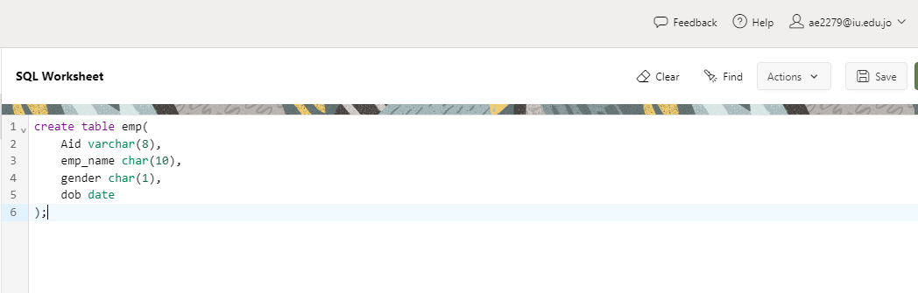

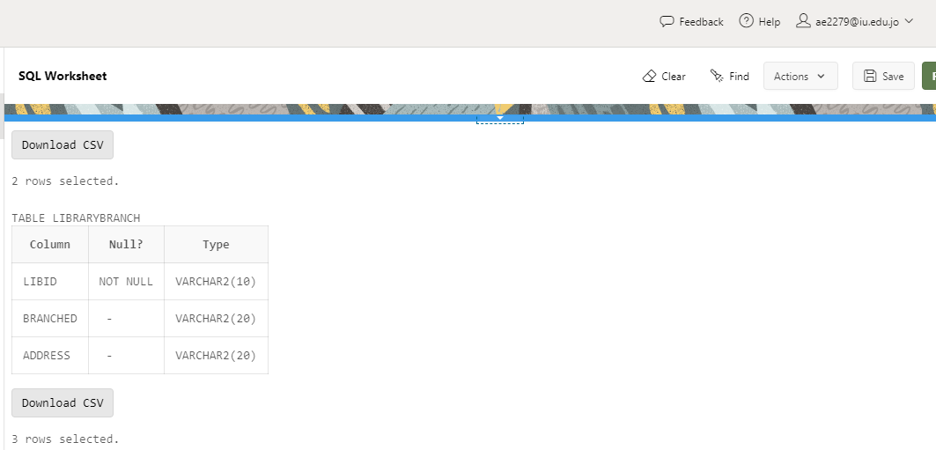

# Exercise 3

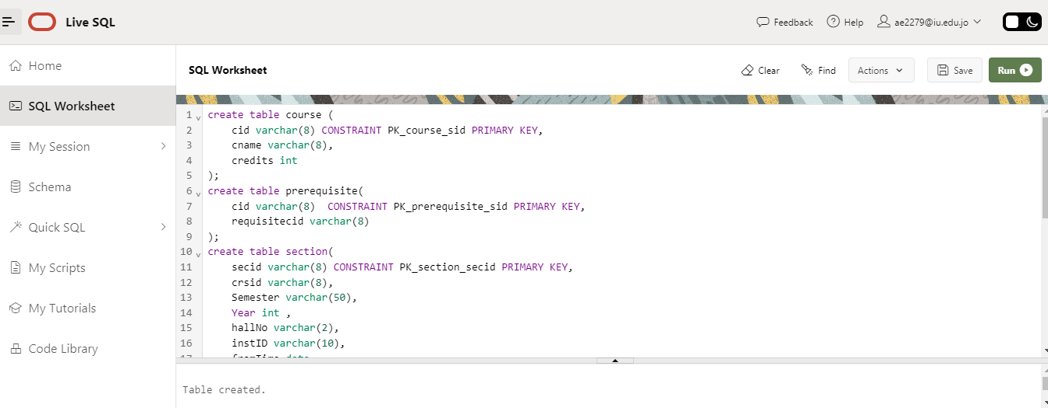

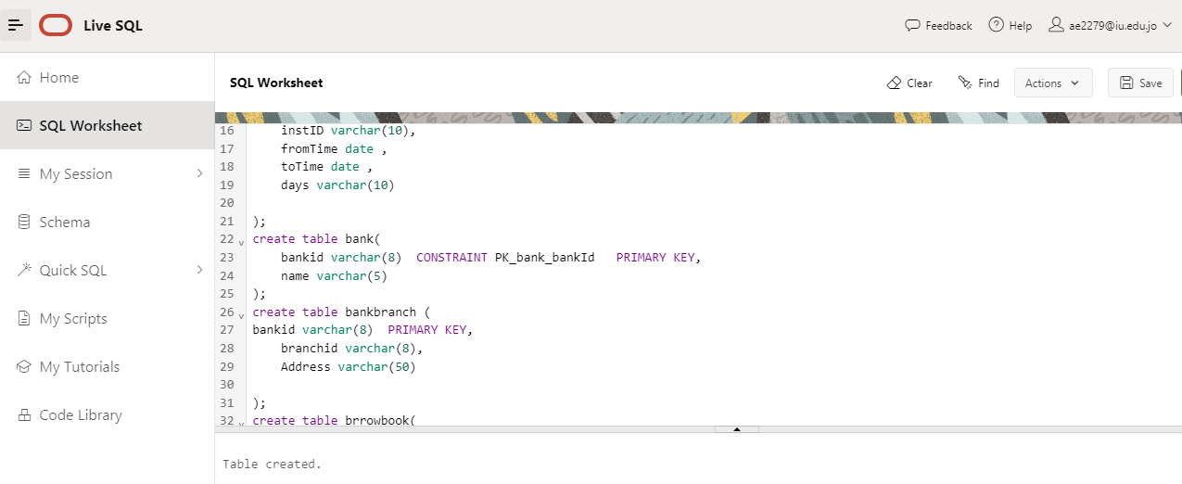

# Exercise 4

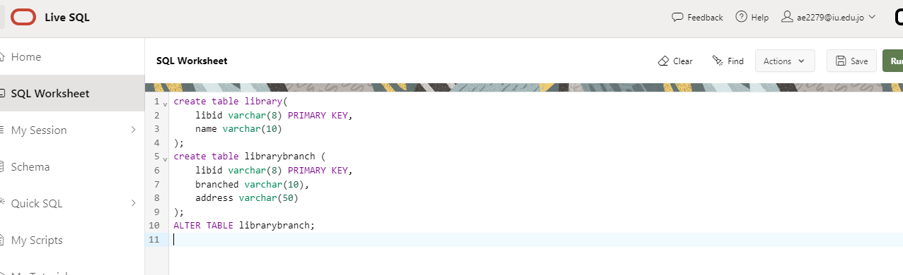

# Exercise 5

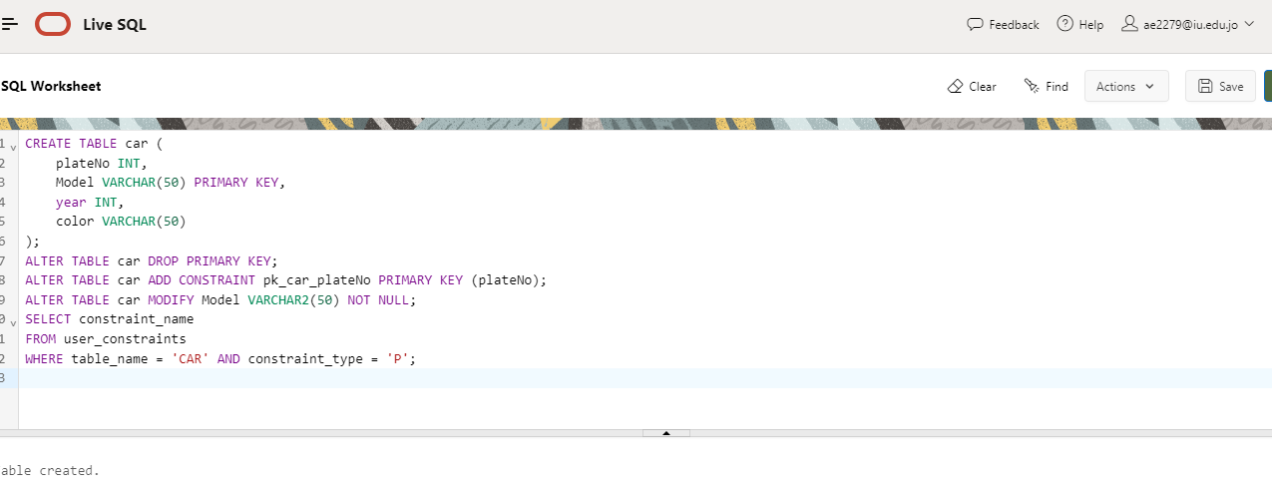

# Exercise 6

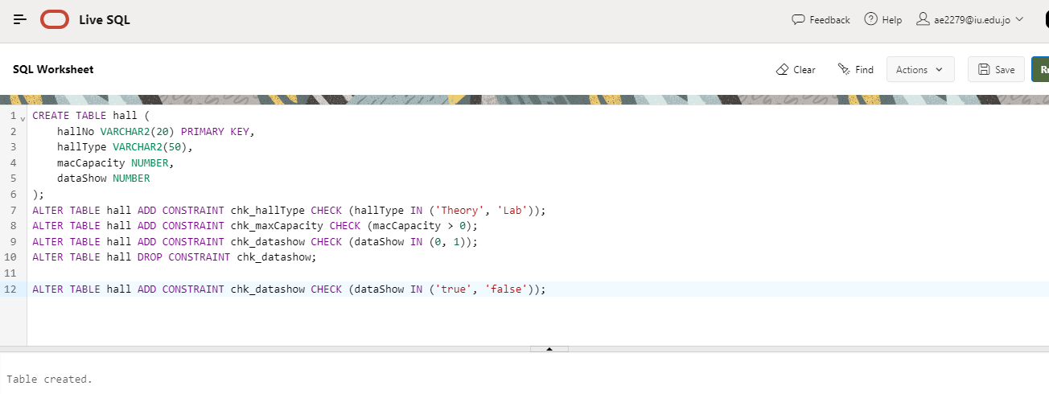

# Exercise 7

